- Objectives
To find the linear absorption coefficient .

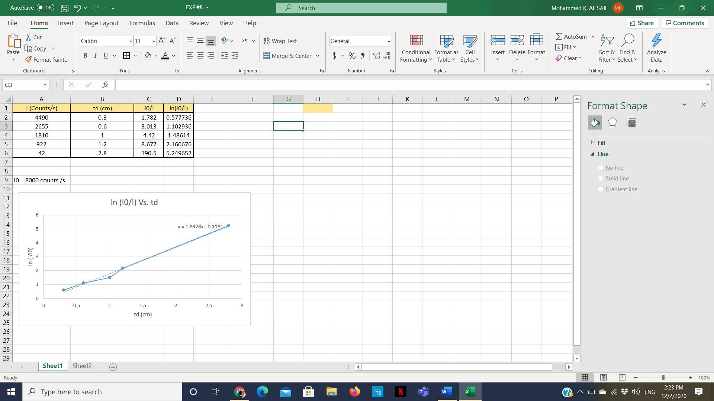
- Result & Discussion

Data were represented using :

Ln ( Io/I ) = µm * td

µL = µm * (Pb density) = 1.8928 * 13.5 = 25.55 cm^-1

%error = (25.55 – 1.07) x 100 /1.07 = 22287% !!!

- Conclusion

To sum up, I used many different representations to achieve such approximate target (µL), but it was very hard to pick one. Because the data are very confusing. Anyhow, I followed the classical approach, i.e., by taking the natural log for both sides of the equation. In another words, I choose to follow the safe side. Despite that, the percentage of error found was unreasonable at all. I will reason that for the high variety between data given.

