King Fahd University of Petroleum & Minerals
Physics Department
PHYS 308 (Term 211)

Final Exam (02 hours, 25/25)
Sunday, January 02, 2022

Clearly circle only the correct answer. Unclear or multiple answers will be considered as wrong.

Problem 1. (2.5/25)
For the following circuit, assuming a constant 0.7 V drop model, determine the value of the diode current when V_{A} = 10 V?
- 8.6 mA
- 9.3 mA
- 0.7 mA
- 5 mA
- 0 mA

Problem 2. (2.5/25)
The following circuit shows a voltage regulator with a zener diode (V_{Z0} = 5V and rz = 50 Ω), a resistor R of 500 Ω, and a load resistor R_{L} of 1kΩ.
Find the variation in output voltage V_{O} if the source voltage V_{S} varies by ± 500 mV.
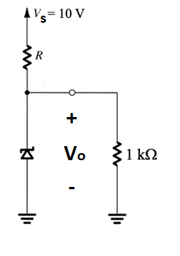

- ± 12.6 mV
- ± 23.4 mV
- ± 43.5 mV
- ± 14.3 mV
- ± 10.7 mV

Problem 3. (2.5/25)
In a full-wave bridge rectifier circuit with filter, the ripple voltage Vr is equal to:
- $V_{r}=(V_{S} - V_{D})/(fRC)$
- $V_{r}=(V_{S} - {2V}_{D})/(2fRC)$
- $V_{r}=V_{S}/(fRC)$
- $V_{r}=(V_{S} - V_{D})/(2fRC)$
- $V_{r}=(V_{S} - {2V}_{D})/(fRC)$

Problem 4. (2.5/25)
For the following circuit, assuming the op-amp is ideal, determine the current I₁ when Vi = 2 V.

- 0.2 mA
- 1.0 mA
- 2.2 mA
- 0 mA
- 2.0 mA

Problem 5. (2.5/25)
The op-amp has the following parameters: A_{OL} = 50,000; Zin = 4 MΩ; and Zout = 50 Ω.
Find the value of the output impedance.

- 380 mΩ
- 620 mΩ
- 160 mΩ
- 720 mΩ
- 980 mΩ

Problem 6. (2.5/25)
The resistor values are R_{f} = 470 kΩ; R₁ = 4.3 kΩ; R₂ = 33 kΩ and R₃ = 33 kΩ.
Find the output voltage for an input of 80 μV.

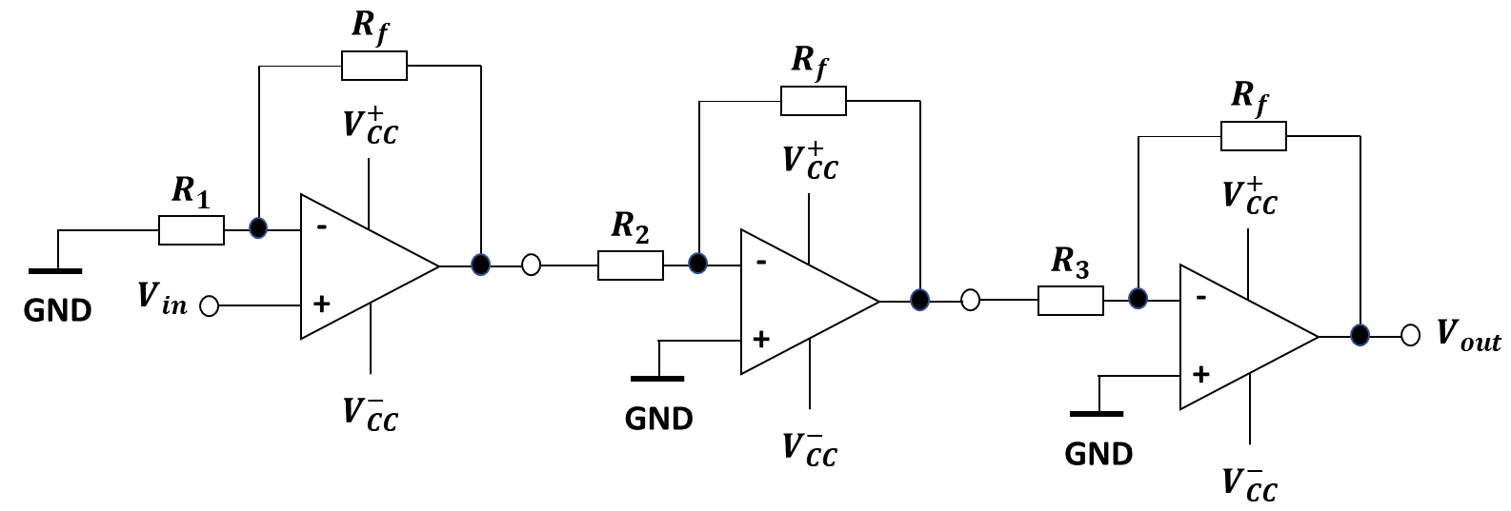
- 2.4 V
- 5.6 V
- 3.3 V
- 1.3 V
- 1.8 V

Problem 7. (2.5/25)
Determine the voltage V_{CE} in the circuit below. Take β = 100.

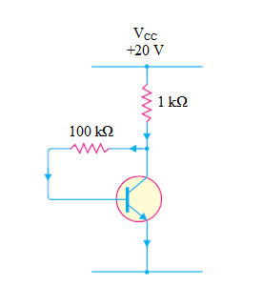

- 10.4 V
- 12.8 V
- 9.50 V
- 8.20 V
- 11.3 V

Problem 8. (2.5/25)
To ensure active mode operation in a NPN BJT transistor, which of the following conditions is true?

- V_{C} < V_{E}
- V_{B} < V_{E}
- V_{C} > (V_{B} - 0.4 V)
- V_{C} < (V_{E} + 0.3 V)
- V_{C} > (V_{E} – 0.7 V)

Problem 9. (2.5/25)
Which of the following statements is NOT TRUE?

- Common emitter amplifier can be used as a voltage amplifier
- Common collector amplifier has very high output resistance
- Adding a resistor in the emitter of common emitter amplifier will reduce the gain
- Coupling capacitors are used to keep the DC bias point unchanged when connecting the load and the source

Problem 10. (2.5/25)
In the circuit shown below, V_{CC} = 5 V, β = 80, R_{C} = 1 kΩ and I_{C} = 2.5 mA, the value of R_{B} is

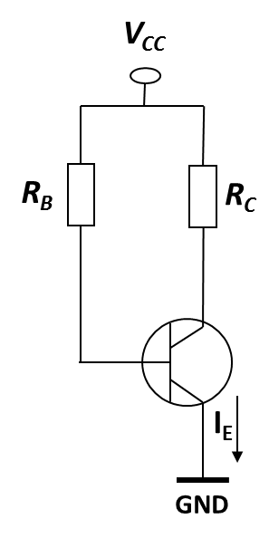

- 137.6 kΩ
- 160.5 kΩ
- 100 kΩ
- 10 kΩ
- 5 kΩ

