King Fahd University of Petroleum & Minerals
Physics Department
PHYS 308 (Term 211)

First Major Exam (1 hour 30 minutes, 15/15)
The solution must contain all the detailed steps and calculations

Monday, October 25, 2021

Always take the value of 0.7 V for Silicon

Problem 1. (2.5/15)

The following circuit uses identical diodes with I_{S} = 1.5x10⁻¹⁶ A, n = 1 and V_{T} = 0.025 V. Use the exponential model to determine the value of Vo when I_{B} = 3.2 mA and R = 1kΩ.
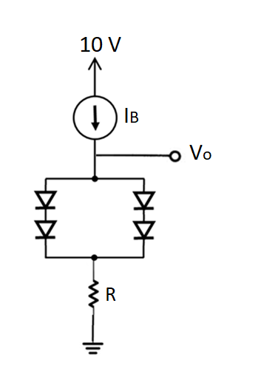

Solution.

$$I_{D}=\frac{I_{R}}{2}=1.6 mA$$

$$V_{D}=nV_{T} ln\frac{I_{D}}{I_{S}}=0.025 ln\left(\frac{1.6×{10}^{-3}}{1.5×{10}^{-16}}\right)=0.75 V$$

$$V_{o}=2V_{D}+I_{B}R=1.5+3.2=4.7 V$$

Problem 2. (2.5/15)

The following circuit shows a voltage regulator with a Zener diode (V_{Z0} = 5V, rz = 50 Ω), a resistor R = 500 Ω, and a load resistor R_{L} = 1kΩ.

- Write an expression for ∆V₀/∆V_{S}.
- Find the variation in output voltage if the source voltage V_{S} varies by ± 500 mV.

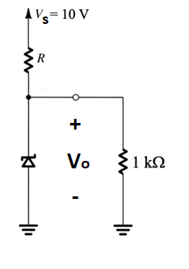

a)

$$\frac{∆V_{O}}{∆V_{S}}=\frac{R_{L}{ r}_{Z}}{\left(R_{L}{ r}_{Z}\right)+R}$$

b)

$$∆V_{O}=∆V_{S}\left(\frac{R_{L}{ r}_{Z}}{\left(R_{L}{ r}_{Z}\right)+R}\right)=±500 mV\frac{47.6}{547.6}=±43.5 mV$$

Problem 3. (2.5/15)

For the circuit below:
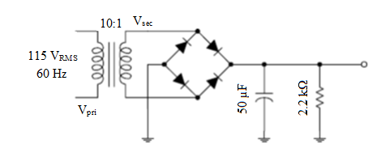

- Find the output DC voltage.
- Determine the ripple factor in percentage.
- Is the capacitor used appropriate for the required ripple factor? Explain
- Determine the load current.

Solution.
See the solution in homework 1.

Problem 4. (2.5/15)

Determine the Q-point for the circuit below and draw the dc load line. Find the maximum peak value of base current for linear operation. Assume β_{DC} = 200.
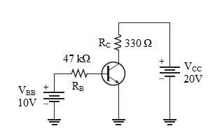

Problem 5. (2.5/15)

Determine V_{CE} and I_{C} in the voltage-divider biased transistor circuit of the figure below if β_{DC} = 100.

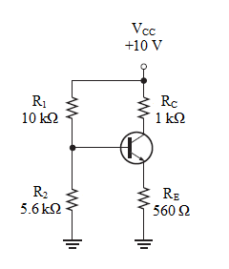

Solution.

$$V_{B}≅\left(\frac{R_{2}}{R_{1}+R_{2}}\right)V_{CC}=\left(\frac{5.6 kΩ}{15.6 kΩ}\right)10V=3.59 V$$

$$V_{E}=V_{B}-V_{BE}=3.59 V-0.7 V=2.89 V$$

$$I_{E}=\frac{V_{E}}{R_{E}}=\frac{2.89 V}{560 Ω}=5.16 mA$$

$$I_{C}≅I_{E}=5.16 mA$$

$$V_{C}=V_{CC}-I_{C}R_{C}=10 V-\left(5.16 mA\right)\left(1.0 kΩ\right)=4.84 V$$

$$V_{CE}=V_{C}-V_{E}=4.84 V-2.89 V=1.95 V$$

Problem 6. (2.5/15)

Determine whether the transistor in the figure below is in saturation.
Assume V_{CE (sat)} = 0.2 V.

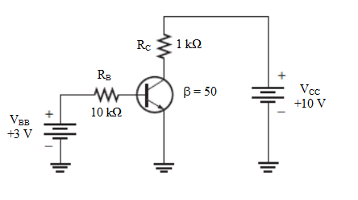

Solution.

First, we determine I_{C(sat)}.

$$I_{C\left(sat\right)}=\frac{V_{CC}-V_{CE(sat)}}{R_{C}}=\frac{10 V-0.2 V}{1.0 kΩ}=\frac{9.8 V}{1.0 kΩ}=9.8 mA$$

Now, we see if I_{B} is large enough to produce I_{C(sat)}.

$$I_{B}=\frac{V_{BB}-V_{BE}}{R_{B}}=\frac{3 V-0.7 V}{10 kΩ}=\frac{2.3 V}{10 kΩ}=0.23 mA$$

$$I_{C}=βI_{B}=\left(50\right)\left(0.23 mA\right)=11.5 mA$$

This shows that with the specified β, the base current is capable of producing an I_{C} greater than I_{C(sat)}. Therefore, the transistor is saturated.

