Problem 1
For the common-emitter (CE) amplification circuit below:
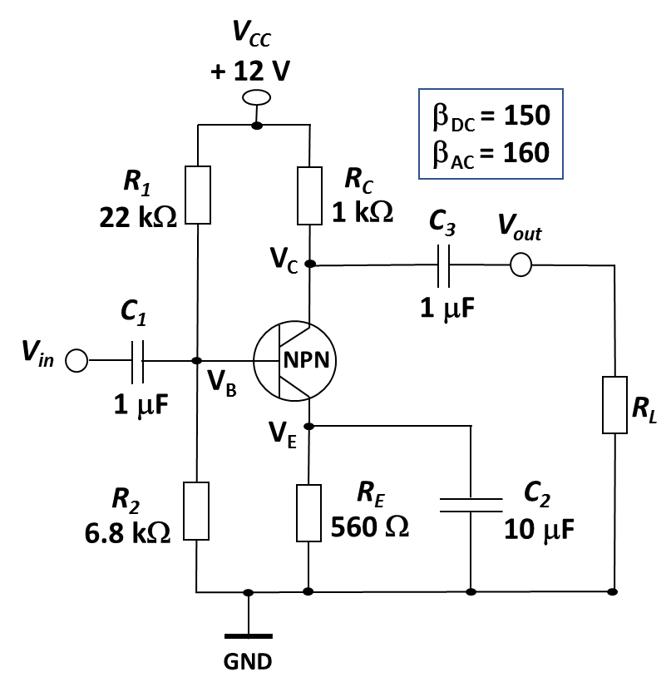
- Determine the bias current $I_{E}.$ 2 points
- Determine $R_{in(total)}$seen by the source ($V_{in}).$ 2 points
- Determine the voltage gain from base to collector without the load ($R_{L}$). 2 points
- Determine the voltage gain from base to collector when a load ($R_{L}=5 k$) is connected to the output. 2 points
- What will happen to the voltage gain when the bypass capacitor is removed? 1 point
- Why is a partially bypassed emitter resistor used? 1 point

Note: In AC analysis, use the simplified T-model of BJT at room temperature.

- 2 points

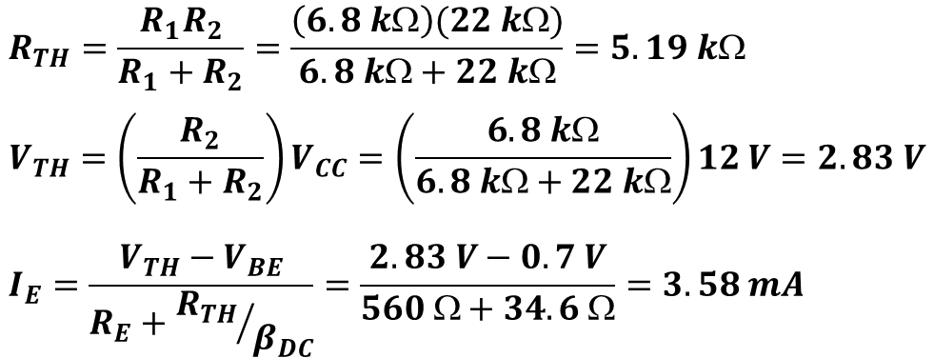

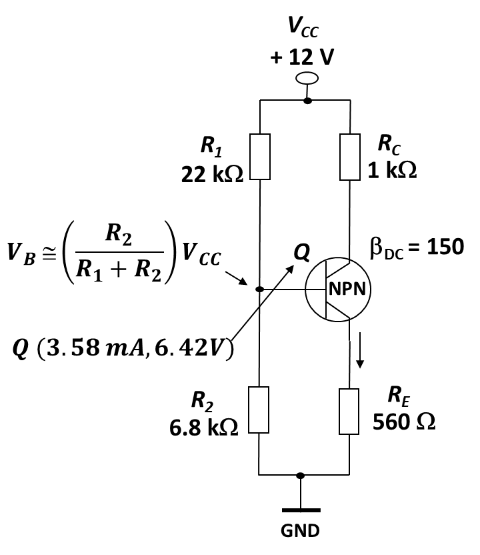
- 2 points
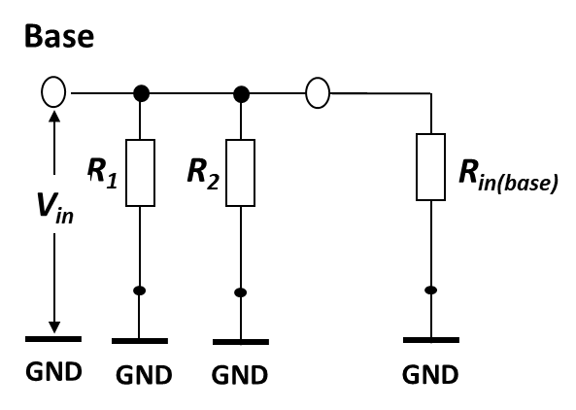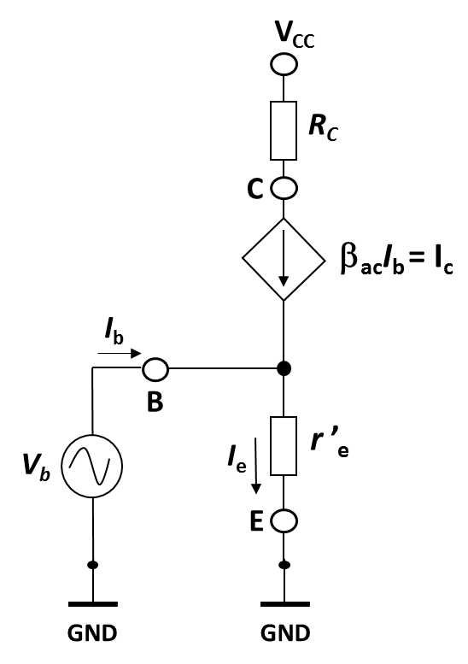
$$R_{in\left(tot\right)}=R_{1 }{ R}_{2} R_{in(base)}$$

$$R_{in\left(base\right) = β_{ac}r_{e}^{'} =160 × 6.98 = 1.12 k}$$

$$r_{e}^{'}=\frac{25 mV}{I_{E}}=\frac{0.025 V}{3.58 mA}=6.98$$
$$R_{in(tot)}=\frac{1}{\frac{1}{22 kΩ}+\frac{1}{6.8 kΩ}+\frac{1}{1.12 kΩ}}=921.3$$
- 2 points

$$A=\frac{V_{c}}{V_{b}}=\frac{R_{C}I_{c}}{r_{e}^{'}I_{e}}=\frac{R_{C}I_{e}}{r_{e}^{'}I_{e}}=\frac{R_{C}}{r_{e}^{'}}=\frac{1 k}{6.98 }=143.3$$

- 2 points

$$A^{'}=\frac{R_{C}{ R}_{L}}{r_{e}^{'}}=\frac{\frac{R_{C}{×R}_{L}}{R_{C}+R_{L}}}{r_{e}^{'}}=\frac{0.83 k}{6.98 }=118.9$$

- 1 point

The voltage gain will be reduced. The effect of R_{E} is to decrease the ac voltage gain. The new gain A will be in this case:

$$A=\frac{R_{C}}{r_{e}^{'}+R_{E}}$$

- 1 point

A partially bypassed emitter resistor used (with $R_{E}$ partially unpassed), the gain is much less dependent on $r_{e}^{'}$.

$$A=\frac{R_{C}}{R_{E1}} \left(without load\right) or \frac{R_{C}{ R}_{L}}{R_{E1}} (with load)$$

Problem 2. (4/10)
The amplifier circuit uses an op-amp with finite gain A of 10. Find V_{out} for V_{in} = 1V.
Take R₁ = 1 kΩ and R₂ = 2 kΩ.

$$V_{out}=A\left(V_{d}\right)$$

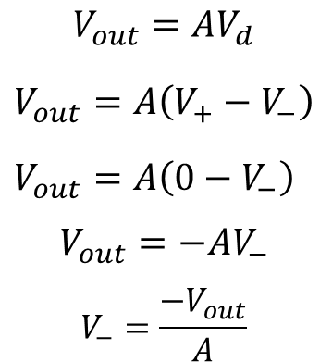
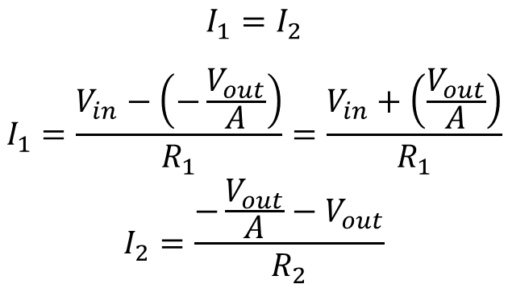
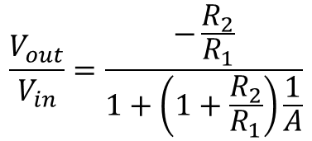
$$V_{out}= -1.54$$

Problem 3. (3/10)
The circuit of a noninverting summing amplifier is shown below. The circuit consists of two inputs $V_{1}$ and $V_{2}$. Calculate the output $V_{out}$ of the amplifier as a function of the two inputs $V_{1}$ and $V_{2}$.

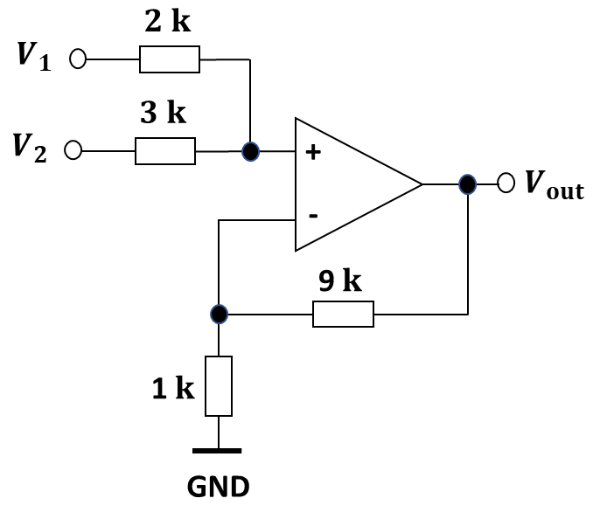

Use superposition principle to find the contribution of V1 to the output voltage (V2 = 0).

$$V_{+}=\frac{3}{2+3}V1=0.6 V1$$

$$V_{out}=\left(1+\frac{9}{1}\right)V_{+}=10×0.6 V1=6 V1$$

Use superposition principle to find the contribution of V2 to the output voltage (V1 = 0).
$$V_{+}=\frac{2}{2+3}V2=0.4 V2$$

$$V_{out}=\left(1+\frac{9}{1}\right)V_{+}=10×0.4 V2=4 V2$$

$$V_{out}=6 V1+4 V2$$

Problem 4. (3/10)
Calculate the voltage gain, current gain, power gain, and input resistance.

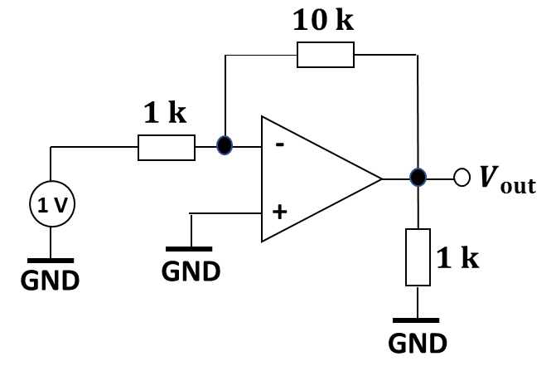

$$i_{1}=\frac{1V-0}{1 k}=1 mA$$

$$i_{2}=i_{1}=1 mA$$

$$V_{out}=0-1 mA×10 k=-10 V$$

$$i_{L}=\frac{V_{out}}{1 k}=\frac{-10 V}{1 k}=-10 mA$$

$$i_{out}=i_{L}-i_{2}=-10 mA-1 mA=-11 mA$$

$$Voltage gain = \frac{V_{out}}{1 V}=\frac{-10 V}{1 V}=-10 (or 20 dB)$$

$$Current gain = \frac{i_{L}}{i_{1}}=\frac{-10 mA}{1 mA}=-10 (or 20 dB)$$

$$Power gain= \frac{V_{out}}{1 V}×\frac{i_{L}}{i_{1}}=-10×-10=100 (or 20 dB)$$

