Solution
Problem 1.

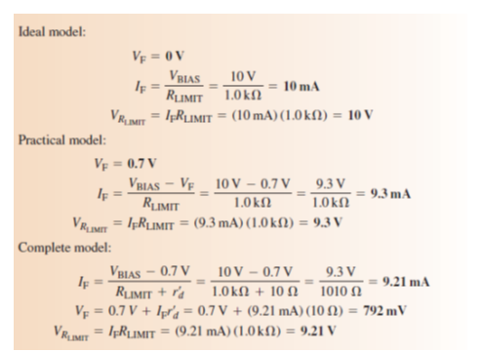

Problem 2.
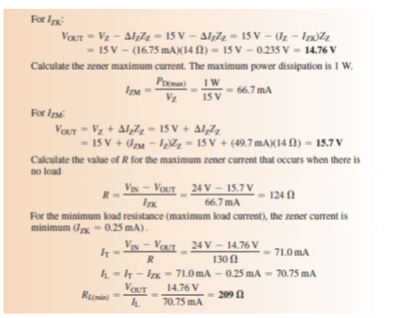
If you take R = 124 Ω, R_{L} is ∼ 198 Ω

Problem 3.

$$V_{p(pri)}=1.414 V_{rms}=1.414 \left(115 V\right)=163 V$$
$$V_{p(sec)}=nV_{p(pri)}=0.1 \left(163 V\right)=16.3 V$$
$$V_{p(rect)}=V_{p(sec)}-1.4 V=16.3 V-1.4 V=14.9 V$$
$$f=2f_{in}=120 Hz$$
$$V_{r(pp)}=\left(\frac{1}{fR_{L}C}\right)V_{p(rect)}=\left(\frac{1}{120×2.2×{10}^{3}×50×{10}^{-6}}\right)14.9=1.13 V$$
$$V_{DC}=\left(1-\frac{1}{2fR_{L}C}\right)V_{p(rect)}=\left(1-\frac{1}{2×120×2.2×{10}^{3}×50×{10}^{-6}}\right)14.9=14.3 V$$
$$r=\frac{V_{r(pp)}}{V_{DC}}=\frac{1.13}{14.3}=0.079→7.9\%$$

$C$ > $\frac{1}{fR_{L}}=3.8µF$
$C$ = $\frac{1}{2\sqrt{2}frR_{L}}=17µF$

$$V_{r}=\frac{I_{L}}{fC}→ I_{L}=V_{r}×fC=6.8 mA$$
$$I_{L}=\frac{V_{P}}{R_{L}}=6.8 mA$$

