KING FAHD UNIVERSITY OF PETROLEUM AND MINERALS
DEPARTMENT OF PHYSICS
PHYS 441-221 Particle Physics
Major Exam-1 Solutions
12/10/2022
NAME
ID #
Q1. (5 points)
An electron of total energy E hits an electron at rest producing three electrons and one positron in the reaction
$$e+e→e+e+e+e^{+}$$
Calculate the threshold kinetic energy (minimum KE) of the incident electron for this reaction in terms of the electron mass m.
Solution
This problem is essentially the same as the one treated in Example 3.4 on page 106 of textbook using protons instead of electrons.
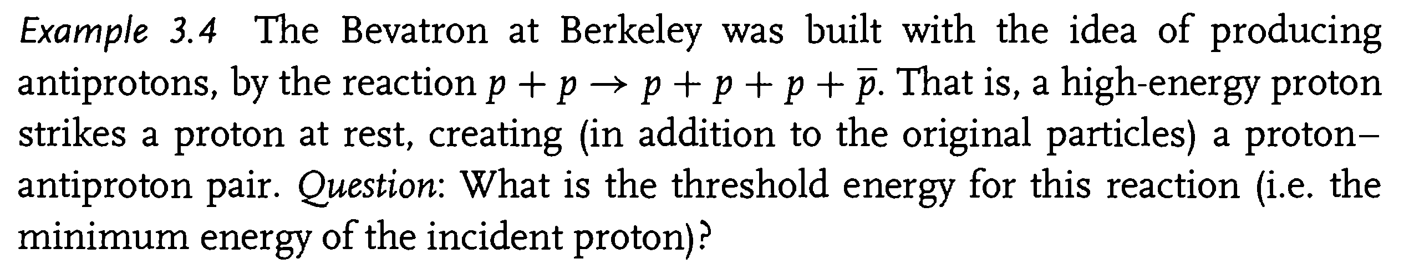
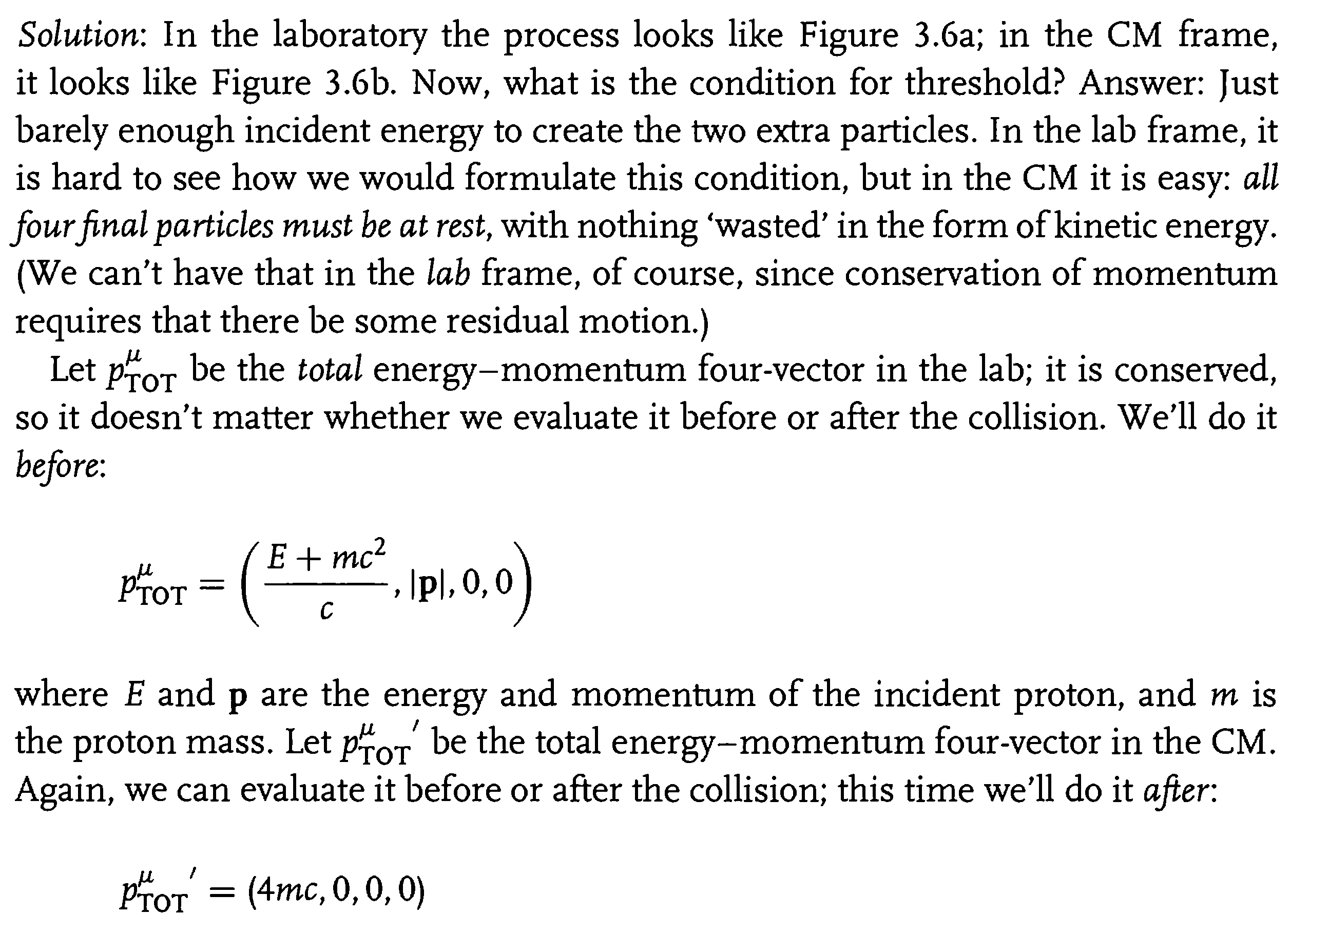
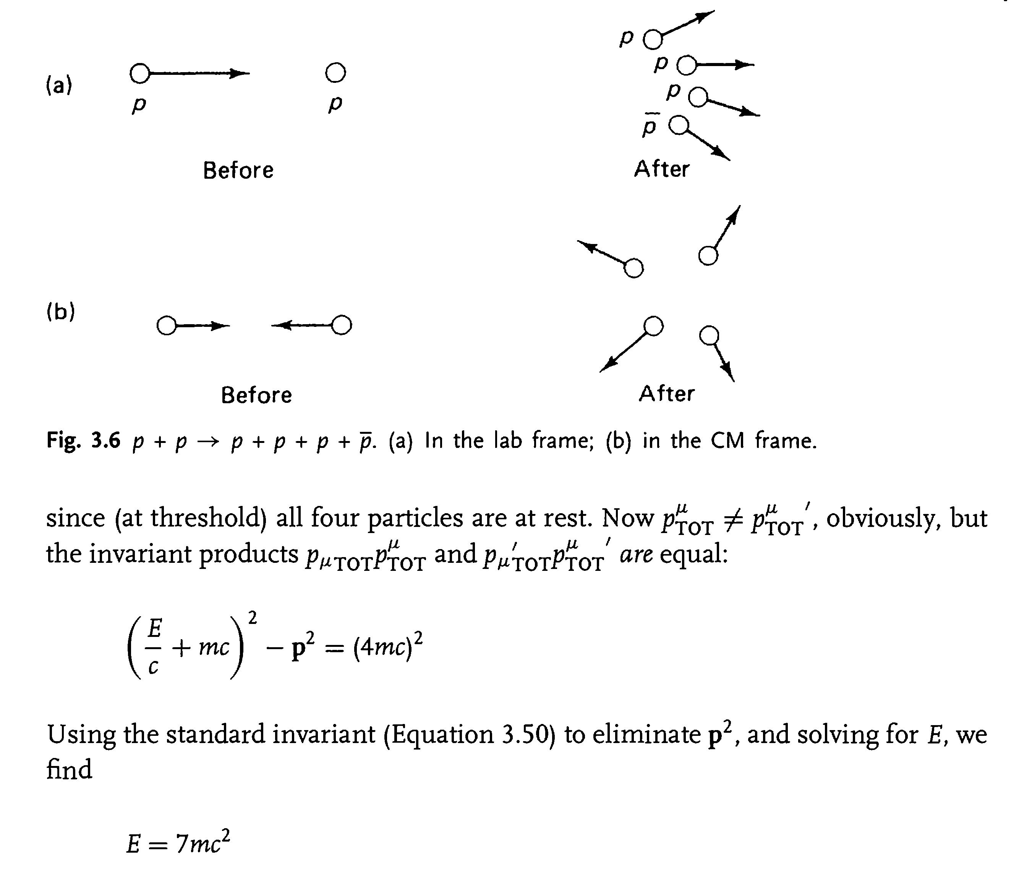
$$KE=E-mc^{2}=6 mc^{2}$$

Q2. (5 points)
Consider the Feynman diagram shown below for $A+A→A+A$ in the ABC toy model:

Using the Feynman rules for this model, find the scattering amplitude M for this diagram, assuming $m_{B}=m_{C}=0$. Leave your answer in the form of an integral over one remaining 4-momentum q.
ADHERE TO THE MOMENTUM CONVENTION IN THE ABOVE FIGURE
Solution

Q3. (5 points)
(a)Determine the lowest-order scattering amplitude for the process $A+B→A+B$. (There are two diagrams)
(b)Find the scattering amplitude for this process in the CM frame, assuming $m_{A}=m_{B}=m, m_{C}=0.$ Express your answer in terms of the incident energy $E$ (of particle $A$) and the scattering angle $θ$ (of particle $A$).
Solution
$$M=-\frac{c^{2}g^{2}}{4}(\frac{E^{2}\tan^{2}\left(\frac{θ}{2}\right)+m^{2}c^{4}}{E^{2}\left(E^{2}-m^{2}c^{4}\right)})$$

