KING FAHD UNIVERSITY OF PETROLEUM AND MINERALS
DEPARTMENT OF PHYSICS
PHYS 441-221 Particle Physics
Major Exam-2 Solutions
14/11/2022; 06:00-08:00 PM
NAME
ID #
Q1. (5 points)
Imagine that the photon, instead of being a massless vector (Spin 1) particle, were a massive scalar particle (Spin 0). Specifically, suppose the QED vertex factor were
$$ig_{e}1$$
(where $1$ is the $4×4$ unit matrix), and the ‘photon’ propagator were
$$\frac{-i}{q^{2}-{\left(m_{γ}c\right)}^{2}}$$
- Find the amplitude, $M$, for electron-muon scattering, in this theory.
- Calculate the spin-averaged quantity, $〈{\left|M\right|}^{2}〉$
Solution
Q2. (5 points)
Solution
Q2. (5 points)
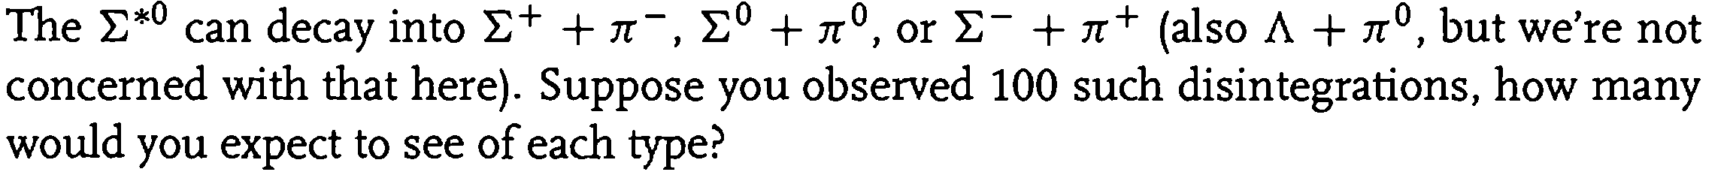
Solution

