KING FAHD UNIVERSITY OF PETROLEUM AND MINERALS-DEPARTMENT OF PHYSICS
PHYS 441-221
QUIZ # 6 Solutions
Full answers taken directly from indicated page(s) of textbook (yours need not be as detailed)

- Name the reason weak interactions are weak
Answer: page 315
- Why is the weak interaction vertex of the form $γ^{μ}\left(1-γ^{5}\right)$, i.e. V-A type?
Answer: pages 308-309, see also comments at bottom of page 309
- What is the lifetime of the muon, approximately?
Answer: page XIII ($μs$ is ok for correct answer)
- Which conservation law causes the decay $π^{-}→e^{-}+{\overline{υ}}_{e}$ to be suppressed compared to the decay $π^{-}→μ^{-}+{\overline{υ}}_{μ}$
Answer: pages 323-324
- What is the value of the Cabibbo angle, approximately?
Answer: page 325
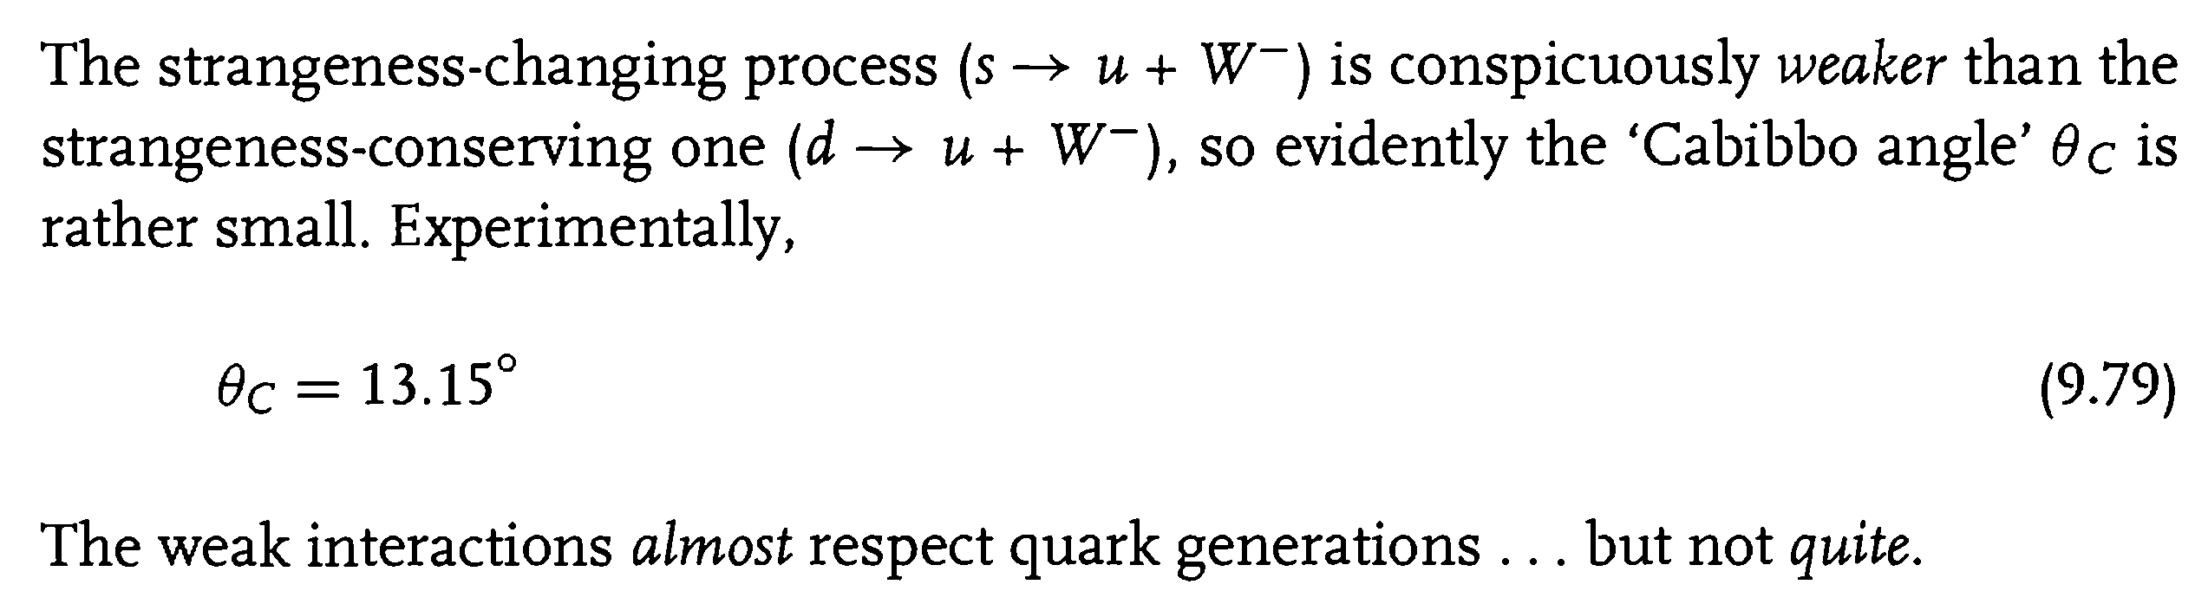
- Which quark was predicted to exist by the GIM mechanism?
Answer: pages 326-327
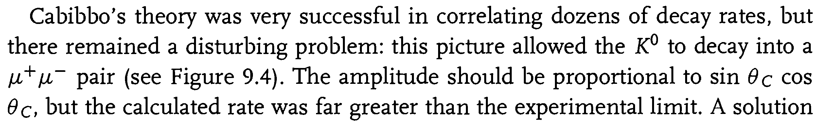
- Which quarks were predicted to exist by Kobayashi and Maskawa?
Answer: page 328
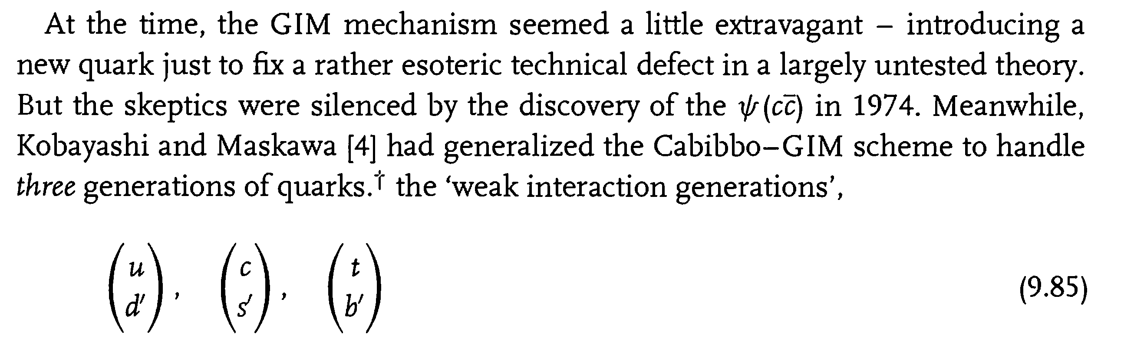

- What is the value of $\sin^{2}\left(θ_{W}\right)$, approximately? $θ_{W}$ is the weak mixing angle.
Answer: page 332
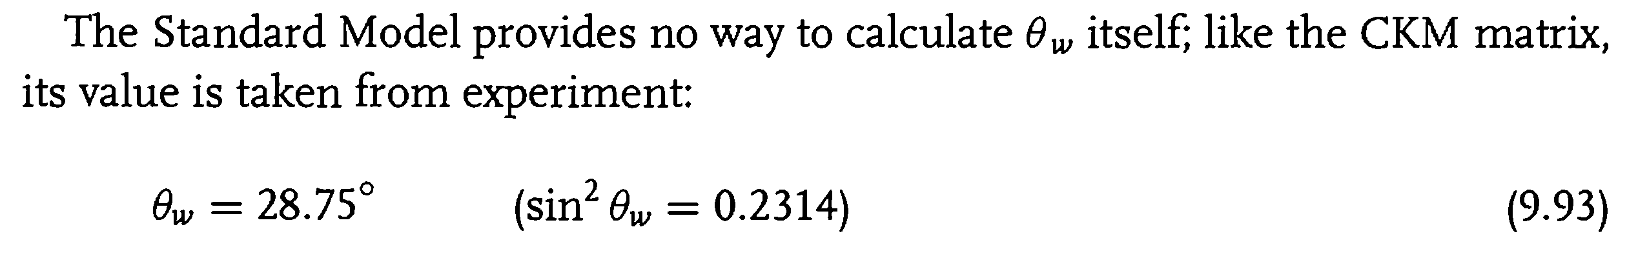

- What type of scattering was used/observed to prove the existence of neutral weak currents? When and Where?
Answer: page 330-331
- When and where were the 3 weak vector bosons discovered? What were their masses?
Answer: page 332
