KING FAHD UNIVERSITY OF PETROLEUM AND MINERALS-DEPARTMENT OF PHYSICS
PHYS 441-221
QUIZ # 7 Solutions
15-12-2022
10 minutes
1 point per question

Give brief answers

Name ID

- Why was there a need to mix the current generated by the 3rd component of weak isospin $\left(j_{μ}^{3}\right)$and the electromagnetic current $j_{μ}^{em}$?

Answer: The Z boson interacts with L as well as R handed fermions

- What is the symmetry group of the electroweak interactions?
Answer: $SU{\left(2\right)}_{L}⊗U{\left(1\right)}_{Y}$
- What are the covariant derivatives for QED and QCD?
Answer:
QED:
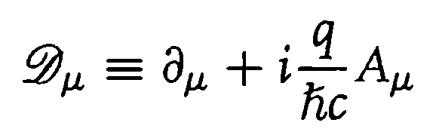
---------------------
QCD:
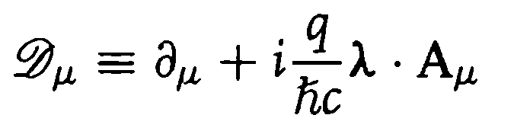
- Why must the gauge bosons be massless?
Answer: To preserve gauge invariance of the lagrangian density
- Explain qualitatively how the $W^{±}$ and $Z$ gauge bosons get their masses?
Answer: spontaneous symmetry breaking and gauge invariance of the lagrangian density, also known as Higgs mechanism.

